Samsung Startup Procedures

One advantage of the Samsung products is that they require a system check function to be initiated and completed before the system can be placed into service. These functions test the system’s basic function of communications and refrigerant circuits. If an issue is present the system will not allow the installer to put the system online until the error is addressed. This greatly reduces potential service issues and increases the reliability of the Samsung product. If you are new to Samsung and not aware of these functions it could cause confusion, wasted time and / or undue frustration at start up.
RAC 1:1 systems require the unit to pass Smart Install, while CAC and Hylex 1:1 systems require the unit to pass Auto Check and FJM systems must pass the Auto Addressing and Pipe Check functions prior to starting and testing the systems. Below is a description for each system start up – commissioning process. It is advisable to always review or reference the outdoor unit’s installation manual for the system you are working on.
RAC: Smart Install
Press mode and power buttons for 4 seconds to initiate the smart install mode.
Progress will be displayed from 0-99
After completion place the system in heat or cool mode to test.
CAC & (AR36BSHUMGMXCV): Auto Check
After power is applied to the outdoor unit, UP will be displayed on the outdoor.
Press the K2 button 7 times consecutively to initiate Auto Check
T
During the Auto check process the display will show “ E “
The process can take from 10 to 30 minutes for completion.
Upon completion of the auto check process the display will display (PASS)
press the K1 (K2) to exit and place the unit in standby mode.
If the system fails Auto Check an error code will be displayed at the outdoor unit.
Resolve the error by referring to the details on the Troubleshooting page about how to troubleshoot for each error code, and then perform the Auto check again.
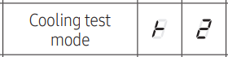
After completion you can run either a cooling test or heating test using the K1 or K2 buttons.
Cooling Test: Press K2 1 time
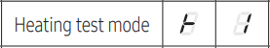
Heating Test: Press K1 1 time.

FJM Start Up and Test
https://www.google.com/search?q=samsung+pipe+check+error&rlz=1C1CHBF_enUS999US999&oq=samsung+Pipe+check&gs_lcrp=EgZjaHJvbWUqBwgAEAAYgAQyBwgAEAAYgAQyBggBEEUYOTIHCAIQABiABDINCAMQABiGAxiABBiKBTINCAQQABiGAxiABBiKBTINCAUQABiGAxiABBiKBTINCAYQABiGAxiABBiKBdIBCTY0NjZqMGoxNagCALACAA&sourceid=chrome&ie=UTF-8#fpstate=ive&vld=cid:c052603a,vid:yFXGgQo7VXE,st:0
Once power is applied the outdoor unit will auto track indoor units and display the unit’s address that it has established communication with. (Address are displayed as Ad --)
After tracking (auto addressing) is completed, the unit will display an E199 code.
Press the K1 button 1 time to initiate pipe check operation.
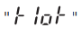
Once completed the unit will display. Press K1 to clear.
The connected indoor unit addresses will appear.
Press the K1 button 2 times to initiate cooling mode trial operation.
Press the K1 button 3 times to initiate heating mode trial operation.
If the system does not pass pipe check an E190 Error will be displayed.

DVM S 3 phase Air Source
https://www.youtube.com/watch?v=WB_Nw0GE9tE
ODU Configuration Set ODU for main or sub (od nd).
Press and hold K1 & k2buttons for 2 seconds to enter the ODU setting function (od 00)
Use the K4 button to set the ODU for:
00 – Main 01 – Sub 1 02- Sub 2
Press and Hold K2 to Save
Enter the indoor unit quantity (Id 00)
Press and hold K1 & k2 buttons for 2 seconds to enter the ODU setting function.
Press K1 till display reads Id 00
Enter the number of IDU’s using the K2 (tens) & K4 (ones) buttons.
Press and hold K2 to save the settings.
Enter the MCU quantity (nc 00) Heat recovery units only.
Press and hold K1 & k2 buttons for 2 seconds to enter the ODU setting function.
Press K1 till display reads nc 00
Enter the number of IDU’s using the K2 (tens) & K4 (ones) buttons.
Press and hold K2 to save the settings.
Auto Pipe Pairing: Heat Recovery only
Press the K2 button 13 times to initiate the auto pipe pairing process. (I-h 00)
The display will start with I-h 00 and progress to I-h 10
The mode of operation is based on the indoor and outdoor temperatures.
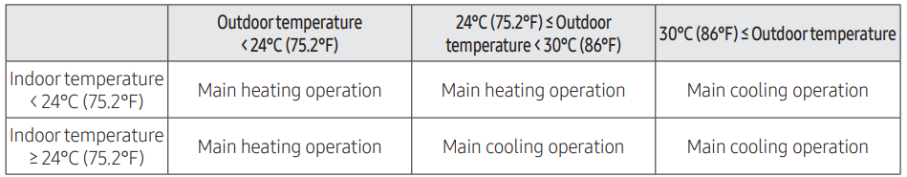
When complete the display will show END

DVM S 3 phase Air Source
(continued)
Auto Trial
The display will show UP
Press and hold K1 for 5 seconds I- I- will be displayed.
The system will initiate the Auto Trail Process
When done the unit will stop and the system will display connected equipment addresses
Heating Test:
Press K1 2 times to initiate the heating test cycle.
Cooling Test
Press K2 2 times to initiate the cooling test cycle.
K3 Button
Use the K3 button to end either the cooling or heat test modes
Press the K3 button to reset the system.

DVM S 3 Phase Air Source Setup
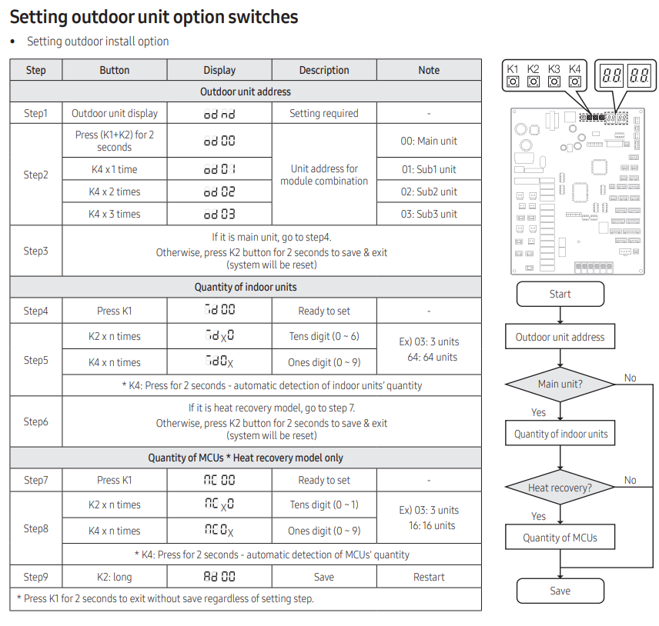

DVM S Eco Startup

Enter the indoor unit quantity (Id 00)
Press and hold K1 & k2 buttons for 2 seconds to enter the ODU setting function.
Press K1 till display reads Id 00
Enter the number of IDU’s using the K2 (tens) & K4 (ones) buttons.
Press and hold K2 to save the settings.
Enter the MCU quantity (nc 00) Heat recovery units only.
Press and hold K1 & k2 buttons for 2 seconds to enter the ODU setting function.
Press K1 till display reads nc 00
Enter the number of IDU’s using the K2 (tens) & K4 (ones) buttons.
Press and hold K2 to save the settings.
HR Setting
Press and hold K1 & k2 buttons for 2 seconds to enter the HR setting function.
Press K1 till display reads ht 00
Press K1 to change the setting:
ht 00 – Heat Pump
hT 01 – Heat Recovery
Press and hold K2 to save the settings.

Auto Pipe Pairing: Heat Recovery only
After E 213 is displayed
Press the K2 button 10 times to initiate the auto pipe pairing process. (I-h 00)
The display will start with I-h 00 and progress to I-h 10
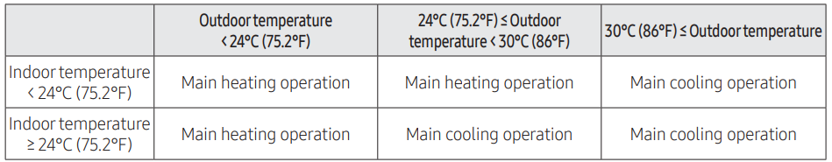
The mode of operation is based on the indoor and outdoor temperatures.
When complete the display will show END
DVM S Eco Startup
(continued)
Auto Trial
The display will show UP
Press and hold K1 for 5 seconds I- I- will be displayed.
The system will initiate the Auto Trail Process
When done the unit will stop and the system will display connected equipment addresses
Heating Test:
Press K1 2 times to initiate the heating test cycle.
Cooling Test
Press K2 2 times to initiate the cooling test cycle.
K3 Button
Use the K3 button to end either the cooling or heat test modes.
Press the K3 button to reset the system.

DVM S Eco Startup
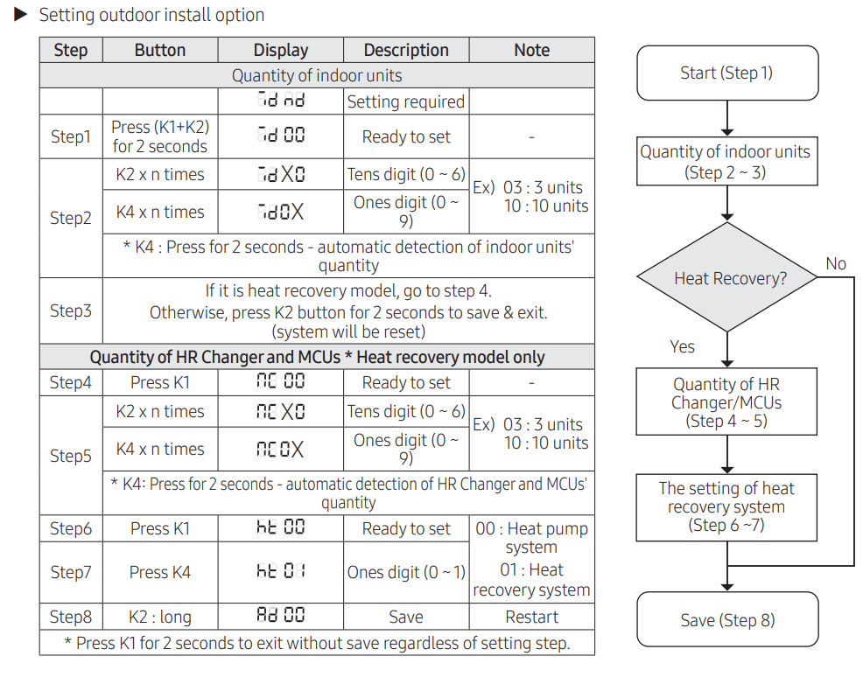

Water Source 3 Phase Startup

ODU Configuration Set ODU for main or sub (od nd).
Press and hold K1 & k2buttons for 2 seconds to enter the ODU setting function (od 00)
Use the K4 button to set the ODU for:
00 – Main 01 – Sub 1 02- Sub 2
Press and Hold K2 to Save
Enter the indoor unit quantity (Id 00)
Press and hold K1 & k2 buttons for 2 seconds to enter the ODU setting function.
Press K1 till display reads Id 00
Enter the number of IDU’s using the K2 (tens) & K4 (ones) buttons.
Press and hold K2 to save the settings.
Enter the MCU quantity (nc 00) Heat recovery units only.
Press and hold K1 & k2 buttons for 2 seconds to enter the ODU setting function.
Press K1 till display reads nc 00
Enter the number of IDU’s using the K2 (tens) & K4 (ones) buttons.
Press and hold K2 to save the settings.
Heat Recovery Mode setting (ht 00) Heat recovery units only.
Press and hold K1 & k2 buttons for 2 seconds to enter the ODU setting function.
Press K1 till display reads ht 00
Press K4 to change the setting:
ht 00 – Heat Pump
hT 01 – Heat Recovery
Press and hold K2 to save the settings.
* When a 3 phase water source system is used for heat recovery the heat pump ball valve MUST be Closed

Water Source 3 Phase Startup
(continued)

Auto Pipe Pairing: Heat Recovery only
Press the K2 button 12 times to initiate the auto pipe pairing process. (I-h --)
The display will start with I-h 00 and progress to I-h 10
The mode of operation is based on the indoor and outdoor temperatures.
When complete the display will show END.

Auto Trial
The display will show UP.
Press and hold K1 for 5 seconds I- I- will be displayed.
The system will initiate the Auto Trail Process
When done the unit will stop and the system will display connected equipment addresses
Heating Test:
Press K1 2 times to initiate the heating test cycle.
Cooling Test
Press K2 2 times to initiate the cooling test cycle.
K3 Button
Use the K3 button to end either the cooling or heat test modes
Press the K3 button to reset the system.

Water Source Setup

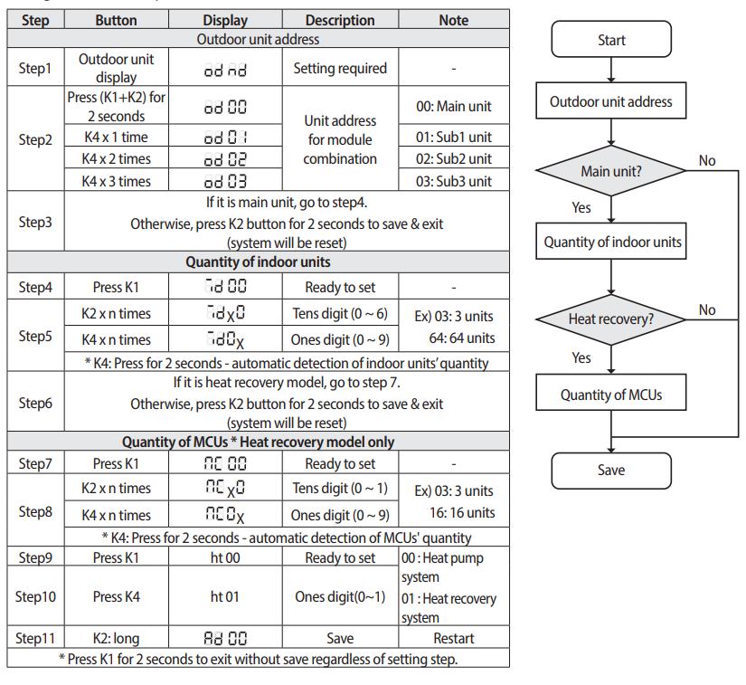

Single Phase Water Startup
Enter the indoor unit quantity (Id 00)
Press and hold K1 & k2 buttons for 2 seconds to enter the ODU setting function.
Press K1 till display reads Id 00
Enter the number of IDU’s using the K2 (tens) & K4 (ones) buttons.
Press and hold K2 to save the settings.
Auto Trial
The display will show UP
Press and hold K1 for 5 seconds I- I- will be displayed.
The system will initiate the Auto Trail Process
When done the unit will stop and the system will display connected equipment addresses
Heating Test:
Press K1 2 times to initiate the heating test cycle.
Cooling Test
Press K2 2 times to initiate the cooling test cycle.
K3 Button
Use the K3 button to end either the cooling or heat test modes.
Press the K3 button to reset the system.

MCU Settings

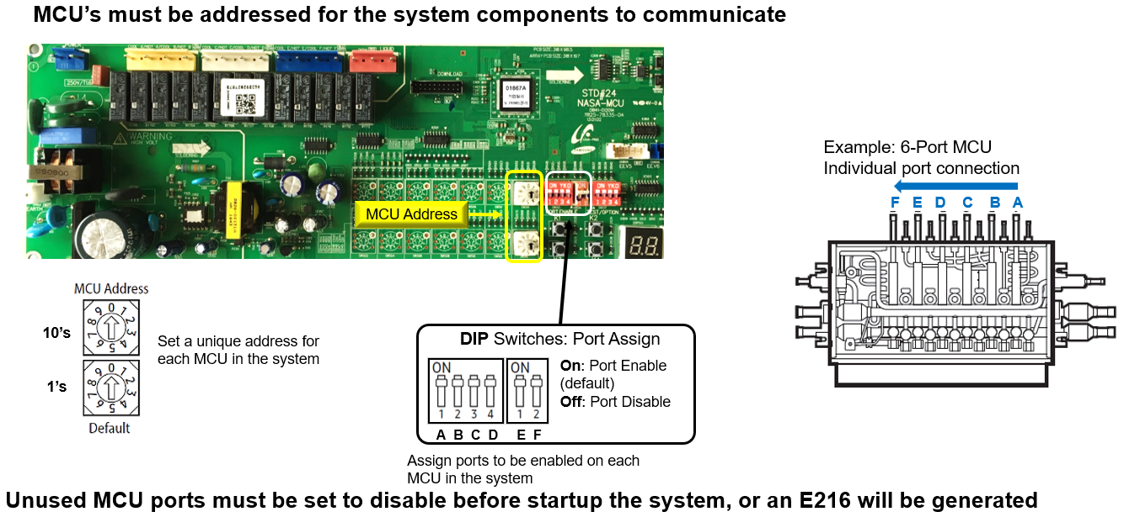

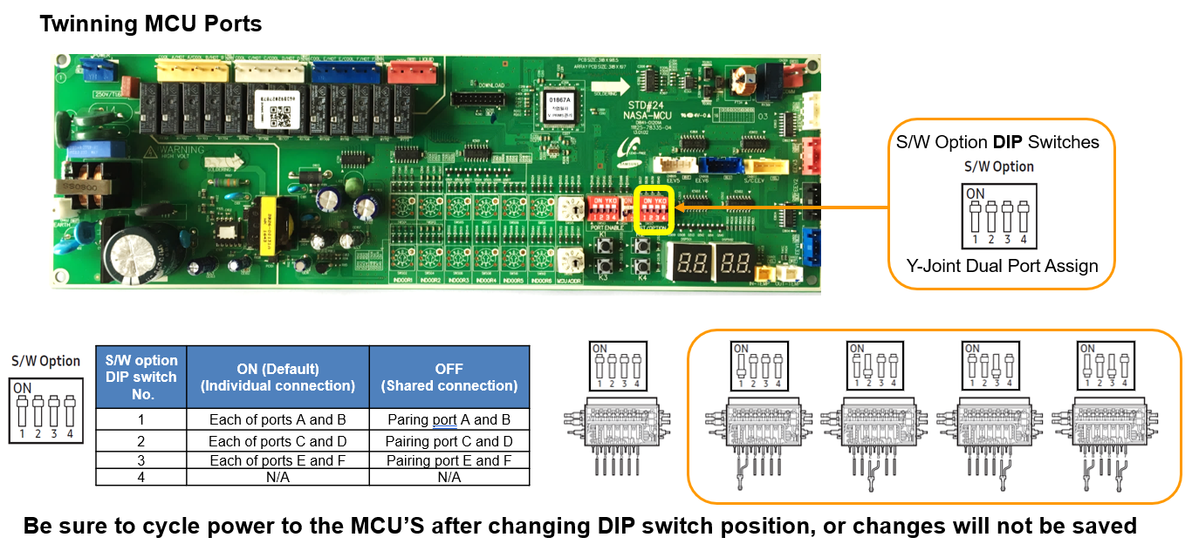

K Button Functions
https://www.youtube.com/watch?v=SO5n8c6gpRM

Hylex Start Up
1 Verify Wiring between the ACU controller, thermostat and IDU.
(The G terminals MUST be connected for the system to work)
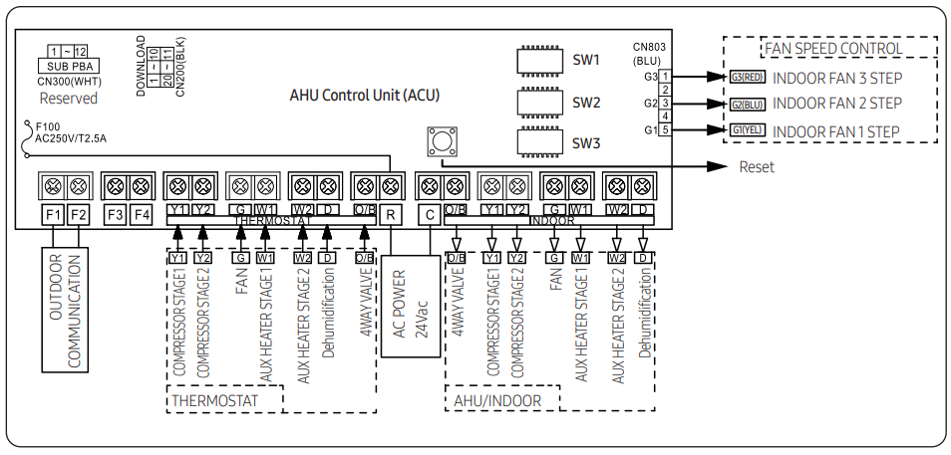
2. Verify the wiring between the ACU controller and ODU. (F1 & F2 16 gauge stranded)
3. Verify Dip Switch settings.
Settings can be found using the Hylex Setup Wizard https://www.samsunghvac.com/unitary-settings

4. Verify the power to the IDU, ACU Controller and ODU
5. The Hylex is uses CAC control so the system MUST go through the AUTO CHECK process
Push the K2 button 7 times – in initiate the Auto Chuck function
During the Auto check process the display will show “/- E “
The process can take from 10 to 30 minutes for completion.
Upon completion of the auto check process the display will display (PASS)
press the K1 (K2) to exit and place the unit in standby mode.
If the system fails Auto Check an error code will be displayed at the outdoor unit.
Resolve the error by referring to the details on the Troubleshooting page about how to troubleshoot for each error code, and then perform the Auto check again.

6. After completion of Auto Check the system can run either a cooling test or heating test using the K1 or K2 buttons.
Cooling Test: Press K2 1 time

Heating Test: Press K1 1 time.

